Nano-Henry Inductance Meter
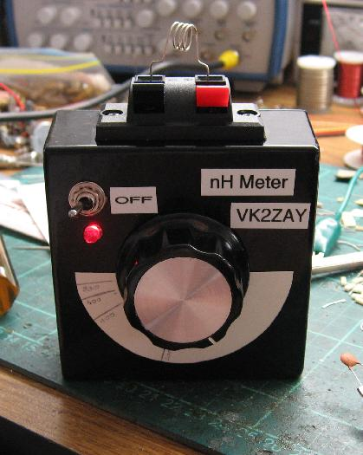
Desiring a simple way to quickly measure inductances in the 10s and 100s of nanohenry for VHF work, I was inspired to build a direct-reading meter like Drew Diamond VK3XU's design "Nano-L" Inductance 'Bridge' for Small Coils. The circuit is published in Volume 2 of his excellent series of books "Radio Projects for the Amateur". I highly recommend you purchase all three volumes, they are great books, I picked up my copies from the recent Wyong Field Day. They can be obtained through the WIA.
I don't know why he calls it a bridge, it is rather a resonance meter, but the name probably comes from its relation to his other true-bridge inductance meter for micro-Henry coils. My implementation is only very slightly different to Drew's, and functions in exactly the same manner. I use a 44.7 MHz TTL oscillator package, as I had some in the junk box. (I actually started out with 80 MHz, but it proved too high for the range of inductances I wanted to measure, with the Lx connection shorted with a piece of brass shim I could peak the meter about middle of the range and a 2" hairpin was beyond its measurement range.)
I also used a "polyvaricon" style capacitor, lacking a suitable air-spaced gang. The detector is identical, and the clean-up resonator values picked for the lower design frequency. I used a spring-loaded speaker terminal block for the Lx connector. I was concerned this would limit its range, but in practice is has proven quite usable, and much more expedient than binding posts.
The circuit is constructed on a piece of unetched PCB board and mounted in a die-cast Aluminium box which came painted glossy black. Four AA cells provide the power supply, the TTL oscillator can is run at the full 6 volts, there is no dropper diode to keep it within spec, it gets warm but doesn't seem to mind.

The Circuit
The case is dominated by the batteries, inside there is much free space. The Lx hot-side connection is made with a fragment of PCB board to minimise the stray inductance and improve the instrument's minimum inductance capability.
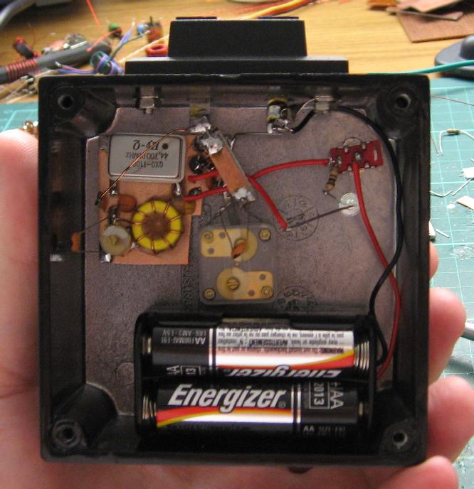
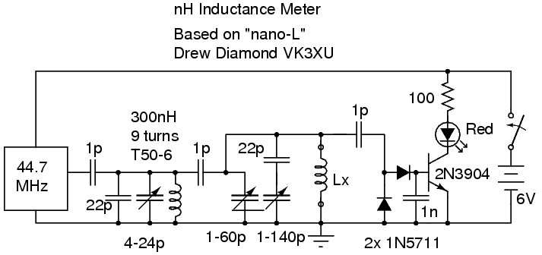

Usage
To use; one connects the inductor to me measured, switches on the unit and sweeps the knob searching for peak brightness of the red LED. The tuning is fairly sharp with moderate-Q inductors, and the peak is generally very obvious, a few degrees off the peak the LED will be completely extinguished.

Calibration
Building the unit is quite easy, but to make it a practical instrument it must be calibrated. You can probably use 5% chokes for the top of the range, but commercial inductors towards the bottom of its range are rare or SMD-only devices.
To calibrate mine I decided to construct a series of calibration inductors of fairly high accuracy, a challenge that exceeds that of building the unit by an order of magnitude!
Having 100p capacitors of fairly high accuracy and stability, I sat down with my LC resonance calculator and came up with resonant frequencies for a geometric series of inductors, resonated with 100p and 400p. As I can measure frequency and capacitance to within about 1% this gave me a way to trim my inductors to the desired values with accuracy beyond what the meter needed.
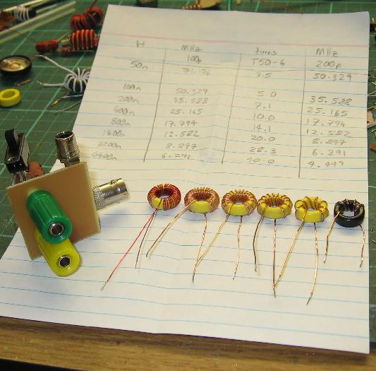
I choose T50-6 cores for the larger inductance values as they offer the best stability/Q/price trade off. The material is suitable for the VHF test frequency, and has a fairly low thermal coefficient. Tx-7 (white) cores are better but much more expensive - I save them for VFOs. A T50-10 core was used for 200 nH, but I may replace this with a air-core inductor as I am unimpressed with its mechanical stability. Values below 200 nH were all air-core, wound with stiff tinned copper wire. All coils were dipped in wax once trimmed to stabilise them. Some experimentation was performed with enamelled wire on soda straws, but the stability was inferior. Repeatability of sub-150 nH inductors is somewhat challenging, even when waxed to a core and the lead length carefully controlled.
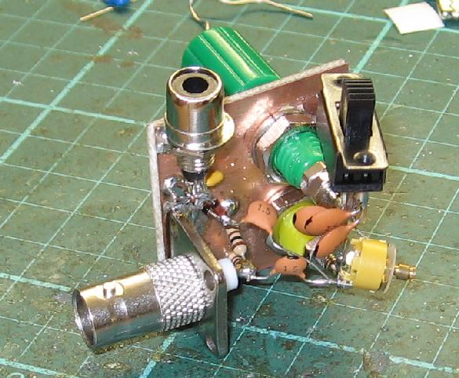
The testing jig in the picture above was specially constructed for the calibration exercise. It allows a trimmed 100p or 400p to be switched across the inductor under test. The signal generator is used as the frequency source, measured with a high-resolution frequency counter than has had its reference zero-beaten against WWVH recently. A CRO or VOM is used to detect resonance, measuring the DC voltage generated by a charge pump. In principle it works a lot like the meter itself, except the capacitance is fixed and the frequency variable.
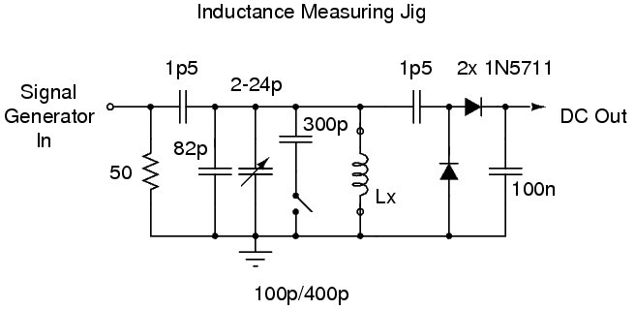
To use, one hooks it up to the detector and signal generator, then measures the capacitance seen across the Lx terminals while trimming it to precisely 100 pF or 400 pF. The capacitance meter is then exchanged for the inductor under test and the signal generator swept to find the resonance peak. Note that in some situations rearranging the circuit to use series resonance would be preferable. One would then tune for a null, which is generally a better proposition anyway, but I used parallel resonance for all my inductors and had little problem achieving high repeatability.
How precise is all this? I am not sure, but I estimate at least 5% with careful use, if not better, as long as you are well below the self-resonant frequency of the inductors.
The testing jig is a useful gadget in its own right, and is usable across a wide range of inductances, it can't hurt to build something similar yourself. Use NP0 capacitors of good quality and their values should be pretty close, even without the ability to measure capacitance. The distributed capacitance of my particular jig was 4.6 pF, so even untrimmed it is still fairly accurate.

